What is a Risk Budget? Process, Components, Benefits
Table of Contents

- What Is Risk Budgeting?
- What is the Purpose of a Risk Budget?
- Components of Risk Budgeting
- Risk Budgeting Process
- Applications of Risk Budgeting in Finance
- Challenges and Limitations of Risk Budgeting
- What are the benefits of risk budgeting?
- Conclusion

The ever-increasing market competition, changing technologies, and multiple other factors have increased the volatility in many ways. So, no matter which domain you work in, you should always expect the unexpected. However, this should not stop you from taking risks! All it takes is a balance between risk-taking and risk mitigation to grow and not worry about unpleasant situations.

What Is Risk Budgeting?
It is a strategic approach used by an organization to manage and allocate resources for a potential threat. You can use a risk budget whenever your business encounters an unpleasant situation. All organizations in finance, project management, manufacturing, or any other domain use the risk budgeting strategy to keep safe against possible vulnerabilities. It is an integral part of the risk management process and involves time allocation, finances, personnel, assets, and other resources. This entire process is conducted by project managers who are proficient in identifying the possible risks and creating effective strategies to mitigate the loss. In the financial context, a risk budget is more like investment management, where the experts diversify the assets and align them with the risk budget. The aim is to optimize returns while managing the possible losses.
However, risk budgeting goes beyond the financial aspect. It encompasses other factors, like operational, regulatory, and reputational risks, in a broader business context. The risk budgeting process involves identifying the potential risks, assessing the level of damage that can happen, and adjusting the business aspects to keep the loss at a minimum.

What is the Purpose of a Risk Budget?
Risk-based budgeting is a strategic tool to proactively manage and allocate resources to mitigate potential risks. The primary purpose of this strategy is to build a structured framework to identify, assess, and address risks of various aspects of a project, investment, or business operation. The fundamental aim of budget risk management is to stay aware and ready to mitigate losses.

Risk Identification and Assessment
The first and foremost purpose is to identify the potential risks beforehand so that there is enough time to plan mitigation strategies.

Resource Allocation
Another purpose is to allocate resources to different risks identified in the assessment process. There are risks in the budgeting process, so only experts can handle allocation efficiently.

Optimizing Risk-Return Trade-off
Optimizing the risk-return trade-off helps organizations improve their competitiveness and helps them grow in a dynamic environment.

Improved Decision-Making
When you know you have covered the risks, your decision-making improves. There will not be any impulse, and you will not make decisions in fear that might prove wrong at a later stage.
In simple words, the crucial purpose is fostering a proactive and systematic approach to handling uncertainties. Through this process, the businesses become powerful enough to stay safe against potential troubles.

Components of Risk Budgeting
Risk budgeting is a comprehensive analytical process involving resource allocation to manage and mitigate potential risks. The process is challenging and includes different components that collectively contribute towards an effective risk management strategy. I will list and explain these components briefly to you.

Risk Appetite
Risks are not a negative term or something to be scared of every time! Sometimes, risks are also the foundation of growth. Whether it gives a productive result depends on how well you calculate your risk appetite. It is the type of risk or the amount of risk a business is willing to take. It is a calculated element, which only an expert decides after carefully analyzing the current company situation and keeping the goals in mind.

Risk Tolerance
It is the level of variability in the ROI (return on investment) the organization can withstand. Most organizations set boundaries of risk tolerance. They use it to make significant decisions. Depending on the financial conditions, investment knowledge, and emotional temperament, it can vary for different companies. If the expert handling the financial aspect of the organization has confidence in his investment knowledge, he might keep an extended tolerance limit because of his expertise in handling risks.

Risk Capacity
As the name suggests, this component is about the ability of an investor or a particular organization to digest losses without any significant impact. It is significant in all types of budget risk to specify the risk capacity for any organization to run its operations smoothly.
It is important for every business to understand the components of risk budgeting thoroughly in order to build fruitful strategies.

Risk Budgeting Process
Risk budgeting is an elaborate process that involves multiple components. This strategic approach is actually a step-by-step process, and the successful execution of each step is essential to get fruitful results.
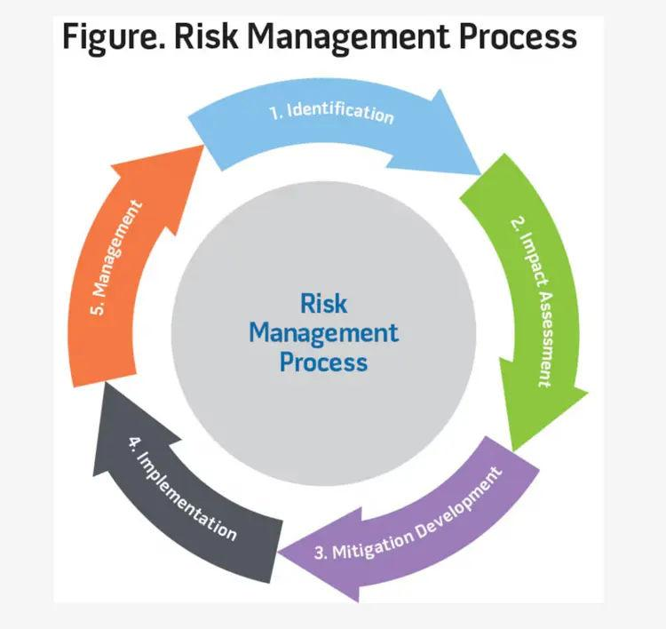

Step 1: Risk Identification
The first step is to identify the potential risks. The experts working on risk budgeting conduct thorough analyses of multiple factors to identify all the risks involved. It can be in different forms, including financial, operational, or compliance-related risks. Identification is where the journey begins. Once you know what can go wrong, you can strategize and decide on best practices to keep the risk under control and eliminate significant losses.

Step 2: Risk Assessment
Once you have identified the risks, the next step is to assess their likelihood or the impact they can have on your business. Experts perform qualitative and quantitative analysis and assign a rating to every identified risk. This process helps quantify the risks in numeric values, giving a better understanding. Based on this assessment, the teams concerned can prioritize the risks and have a detailed knowledge of effective budgeting.

Step 3: Risk Tolerance and Appetite
By now, you know the potential risks, their impact, and priorities. The next step is to determine how much risk your business can withstand. Understand that sometimes, risks also lead to desired growth. So, you don’t have to avoid risks; learn to strategize and get the perks out of it. Establish risk tolerance and appetite to define the acceptable level of variation. These parameters guide decision-makers in determining the acceptable level of risk exposure and influence resource allocation.

Step 4: Resource Allocation
With a clear awareness of potential risks and the appetite your business has, you can move forward to the mitigation process. So, the next step in the process is to allocate resources to address risks. Resources include financial capital, human resources, technology, time, and software systems, and this list is never-ending.

Step 5: Review
The last step is to conduct periodic reviews of the risk budget to check its relevance and effectiveness. Qualified experts conduct a sort of audit to verify that their strategies are working in the direction of desired business goals.
In any budget risk example, you will see that the experts follow this reliable step-by-step process to keep the risks under control yet explore the growth that risk-taking brings.

Applications of Risk Budgeting in Finance
Risk budgeting is an integral part of the financial sector. It helps financial institutions and investors strategically manage and allocate resources to navigate the uncertainties inherent in the financial markets.

Constructing Portfolios
Risk budgeting is effectively used in building strong investment portfolios. It involves allocating capital across different asset classes, considering the risk expectation and return profiles. Your portfolio manager will optimize the overall risk-return trade-off to ensure the portfolio aligns with your investment objectives.

Performance Attribution
Another application of risk budgeting is in performance attribution analysis. It helps to evaluate the overall contribution of individual investments or strategies to portfolio performance. Once the investors know the risk sources, they can facilitate better and well-informed decisions.

Asset Allocation
In asset allocation strategies, risk budgeting plays a crucial role. It allows portfolio managers to adjust asset allocations on the basis of changing market conditions and risk factors. The flexibility it offers enables the portfolio to respond proactively to evolving economic and market dynamics, optimizing the allocation of resources to mitigate potential risks.

Sovereign Wealth Funds
Pension or sovereign wealth funds also use risk budgeting to manage long-term risks. These funds can achieve their long-term objectives by allocating risk budgets all across this investment class. If risk budgeting is efficient, one can mitigate the risk of potential losses.
Every risk management budget example in the financial sector will prove that it is a versatile tool. It can help manage and mitigate risks within investment portfolios and financial departments.

Challenges and Limitations of Risk Budgeting
Preparing a risk budget is a valuable and widely used approach for managing uncertainties, but it has its own challenges or limitations. Every expert building this approach should be aware of these limitations to get fruitful results. Some of the challenges you should know are:
- The quantitative and qualitative analysis is a complex process. There are multiple calculations and huge amounts of data involved, making it more complicated. One requires precision and a hands-on understanding of the industry for accurate results.
- There are quantitative risk models involved in risk budgeting, which may show limitations during unexpected market conditions. These models use historical data, and unexpected developments may impact the accuracy.
- Another challenge is in the operations! Implementing the risk budgeting systems requires tons of resources and hands-on expertise. So, if the company lacks experienced teams, it may face multiple operational challenges.
- It emphasizes historical data a lot. All the decisions are based on past information. However, it doesn’t always guarantee future results. Market conditions and trends might change, and your budgeting will prove futile.
- Some risk models believe that asset returns always follow a normal distribution. However, the truth is that financial markets often exhibit fat tails. This means that the frequency of extreme events is higher than the predicted normal distribution.
- Risk budgeting models are complex. So, it might get challenging to understand these models, which will ultimately affect the strategies that you build using them.
Though there are significant challenges in the process, there are still enormous benefits of this process.

What are the benefits of risk budgeting?
You will find numerous benefits of risk management, and it contributes significantly to the overall success and sustainability of a business. I have listed a few advantages for better clarity.
- Asset & Resource Protection
When you identify the risks beforehand and plan to manage them well, you actually protect the organization’s assets and resources. The risk budgeting strategies you build help protect financial resources, intellectual property, physical assets, and even human resources.
- Improved Decision-Making
The clarity about the potential risks and the organizational capacity to tolerate risks sort your decision-making process. It helps you make fruitful plans and divide the resources in a way that contributes towards business growth.
- Excellent Financial Performance
Effective risk management keeps your finances sorted and minimizes the impact that even the most unpleasant situations might cause. When you have secured your financial aspects, your profitability increases, and you gain long-term financial stability.
- Enhanced Reliability
An organization that shows a proactive approach toward risk management earns enhanced reliability for all the stakeholders. So, with efficient risk budgeting, you gain the confidence of your employees, customers, and investors as your credibility increases many folds.
- Better Growth Graph
It enables you to take calculative risks and implement all the innovative opportunities to support business growth. This expansion will be strategic and sustainable without any fear of an unexpected situation changing the dynamics.
- Disaster management
The crisis is spontaneous and unavoidable sometimes. So, it is always essential to keep a disaster management plan ready, even if you have taken all the precautionary measures. Risk budgeting enables you to prepare an efficient and effective response, ensuring you sail through unpleasant situations smoothly.
- Fruitful Project Management
Identifying the risks and preparing a management strategy helps in successful project delivery. It minimizes the delays and keeps you safe against cost overruns. Furthermore, you sort all the quality issues through a risk budgeting process.

Conclusion
In summary, risk budgeting is a proactive and strategic approach that contributes to organizational success. It forms the basis for making informed decisions, protects assets, and helps navigate through unexpected events smoothly. There is a step-by-step process for making a risk budget that includes the identification of potential risks, assessing them quantifiably, and preparing strategies to mitigate the loss. It is crucial for every organization to work on this strategy-building process as the market is prone to crisis, and anything undesirable can cause irreparable damage. Thus, they hire expert professionals with specialized certifications to their name who are able to assess things well and create a strategy that will benefit the organization in multiple ways and open the doors to take calculated risks.

Frequently Asked Questions (FAQs)

1. How does risk budgeting differ from traditional budgeting?
Traditional budgeting is about financial planning in which you express your financial goals in quantifiable terms. On the other hand, risk budgeting is about covering up all the potential risks and not letting them impact the business negatively.

2. What tools and techniques are used in risk budgeting?
The techniques used in risk budgeting include risk measurement, risk attribution, and allocation. You can use multiple tools for this process, like SWOT analysis and risk register, and this list is never-ending.

3. How frequently should a risk budget be reviewed or adjusted?
You can review or adjust your risk budget annually or semi-annually.

